**Day 3 – E-Mail Service**

1. Research the following internet protocols related to e-mail services.
   1. **SMTP Protocol**

SMTP is the protocol used to send mail from one computer to another. When you’re using a desktop email program like Thunderbird, it’s the protocol used when you hit “Send” to transfer your email message from your computer to that of your email provider. What most people don’t realize is that it’s also the protocol used behind the scenes to transfer your message from server to server as it makes its way to the server on which your recipient receives email. Configuring an SMTP server generally requires the same three things you needed for POP3 or IMAP:

* The name of your email provider’s server which will accept your outgoing email. It could be the same as your POP3 or IMAP server, or something different.
* The account ID you were assigned by your ISP. Most commonly it’s your email address, but it doesn’t have to be.
* Your password.
  1. **POP3 Protocol**

A communications “protocol” is just the language computers use to talk between themselves. POP — the post office protocol — is the language used between a computer fetching email (usually your computer, running an email program) and the computer holding your email (usually that of your email service provider or ISP). A “POP client” is a program fetching email. Thunderbird and Microsoft Office’s Outlook desktop program are two examples. A “POP server” is the server holding your email. The “3”in POP3 turns out to be pretty boring. It indicates that we’re all using version three of the POP protocol. It underwent a few revisions before it became what it is today.

* 1. **IMAP Protocol**

IMAP is another protocol used by email programs to access your email. IMAP is an alternative to POP3, and works in a fundamentally different way. Those differences make it a frequently-preferred alternative in today’s always-connected world.

* 1. **Web Mail**

All of this only applies to email programs you run on your own computer, like Microsoft Office Outlook, Thunderbird, and others. Web-based email, such as Outlook.com, Yahoo, and the like, displays the email directly from their servers to your web browser. There’s no configuration needed other than logging in. They may use SMTP (and perhaps even IMAP or POP3) behind the scenes to get and send email, but that’s nothing you’d ever need to see, know, or worry about. The one exception is that many services can be instructed to act like a desktop email program and fetch your email from an email service. For example, say you normally get your mail from randomisp.com, and use Thunderbird to download that email to your PC, using the POP3 protocol. You can, if you like, open a Gmail account and configure this web-based system to fetch your email from randomisp.com, using POP3. That way, instead of reading your email in your

desktop email program, you would read it by visiting the Gmail website in your browser.

1. Use the following resource as a starting point:  
   <https://askleo.com/what_is_pop_or_pop3_or_a_pop_account_and_what_about_smtp/>
2. Complete the following Venn Diagram to summarize your research.

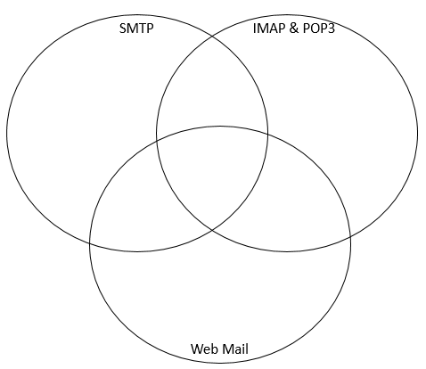

It’s also the protocol used behind the scenes to transfer your message from server to server as it makes its way to the server on which your recipient receives email.

When you’re using a desktop email program like Thunderbird, it’s the protocol used when you hit “Send” to transfer your email message from your computer to that of your email provider.

SMTP is the protocol used to send mail from one computer to another.

All of them use a type of mail

They all use login

They are used by users.

* Web-based email, such as Outlook.com, Yahoo, and the like, displays the email directly from their servers to your web browser.
* There’s no configuration needed other than logging in.

They may use even IMAP or POP3 behind the scenes to get and send email.

They may use SMTP behind the scenes to get and send email.

IMAP assumes you want to leave the master copy of your email on

the master copy of your email on the email server. It’s ideal if you want to access the same email account from several devices.

POP3 is designed around the assumption that when you access your email, you want to download it to the computer you’re using. So after your email program fetches email via POP3, that email resides only on your computer and nowhere else.

Configuring an SMTP server generally requires the same three things you needed for POP3 or IMAP